Activity #1: Can you solve the riddle?! Please write down 3 possible guesses before decoding the answer using the cipher.

____________________________ ____________________________ ____________________________
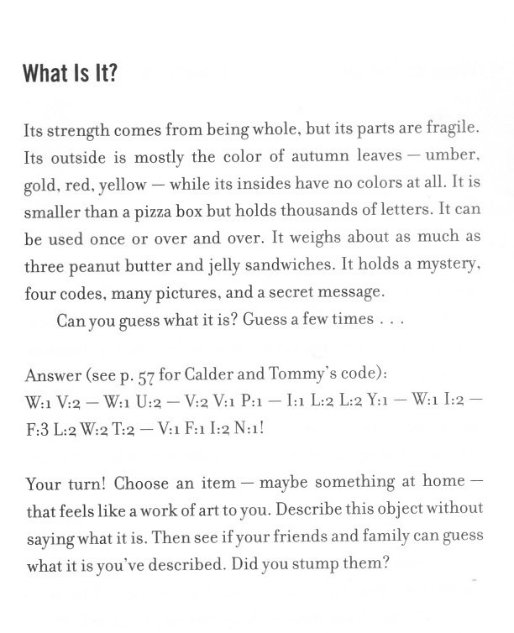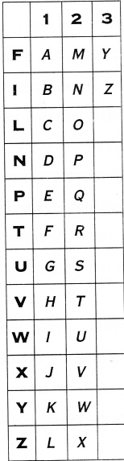

Activity #2: Write your own riddle!

Activity #3: Write the answer to your riddle using Calder and Tommy’s secret code.

Activity #4: Please send us your:
1. Three guesses to the first riddle 2. The answer to the first riddle
3. The riddle YOU wrote 4. The answer to your riddle in coded message.

