One of these paintings is by Vermeer and one is a fake. What do you notice?
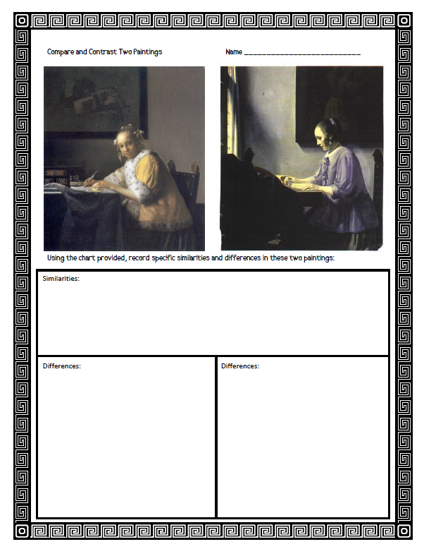

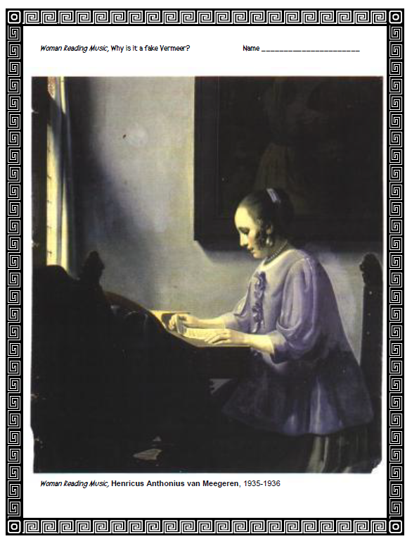
Did you notice that at the bottom of this painting is lists the artist as Anthonius van Meegeren? This is NOT a painting by Vermeer. Now think about the differences you noticed between the real Vermeer and this fake Vermeer.
