Activity #1 – Create your own Secret Code!

Well, I know we’ve all had fun cracking the codes throughout Chasing Vermeer, but now it’s time for you to come up with your own secret code! Use your F2OE (fluency, flexibility, originality, and elaboration) to create a code that works the way YOU think. Remember, with creativity there are no wrong answers! However, you must create a cipher that will work EVERY TIME someone needs to crack your code.
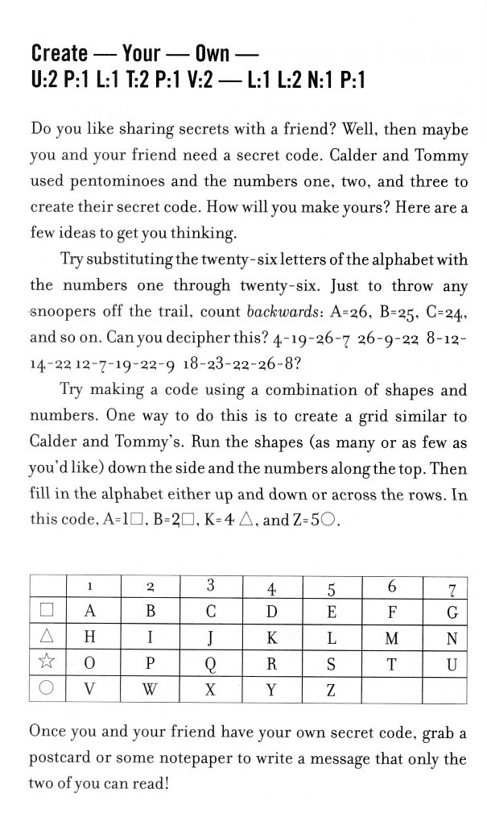
*Scroll down to the next page.*

Here is another copy of the pentomino cipher Calder and Tommy created as an example of one way to create a code.
Calder and Tommy used the pentomino names on the side and numbers at the top. Then they matched each letter of the alphabet up with a pentomino and a number.
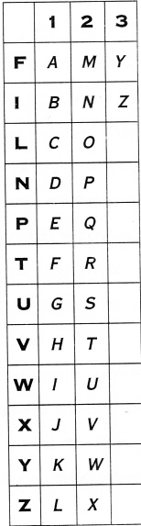

Remember, these are just examples! I want you to create a code that is all your own and is not already shown on this page. Will you match up letters, numbers, or symbols to make your code? Will you create a new picture to represent each letter of the alphabet? (Think hieroglyphics! …only remember to make each picture easy enough to write repeatedly. Do you remember how hard it was writing in hieroglyphics?!)
Here is a fun website with some more inspiration: https://picklebums.com/secret-codes-for-kids/
At the bottom of the website there is a heading that reads, “More Cool Secret Code for Kids.” Under this heading there are 5 more awesome websites to take a peek at.
Good luck and have fun creating!

Activity #2 – Write me a message using your new secret code! Don’t forget to also send me a copy of the cipher so I can crack it.

