Sound the Alarms!!! 

The Mona Lisa has been stolen from the Louvre Museum!!

Watch this to learn about the Mona Lisa: <https://www.youtube.com/watch?v=dCOI90wO_3o>

Now watch this about the theft of the Mona Lisa: 😊 <https://www.youtube.com/watch?v=Ips5LbPtglQ>

And this slightly different version: <https://www.smithsonianmag.com/videos/category/arts-culture/the-man-who-stole-the-mona-lisa/>

Let’s pretend the Mona Lisa has been stolen again! Your task – recreate the painting! How can you put your own artistic twist on this famous piece of art? What color will her hair be? Will it be long or short? What will her clothes look like? Where is the setting of the painting? Is she in outer space or in the wild west? Is she in the jungle, medieval times, or ancient Egypt? Has she been transformed into your favorite character? YOU are the artist, so you get to make all the decisions!

Here are a few examples from my students last year to give you some inspiration! Please do not copy their ideas. I want to see what YOU can come up with! 😊

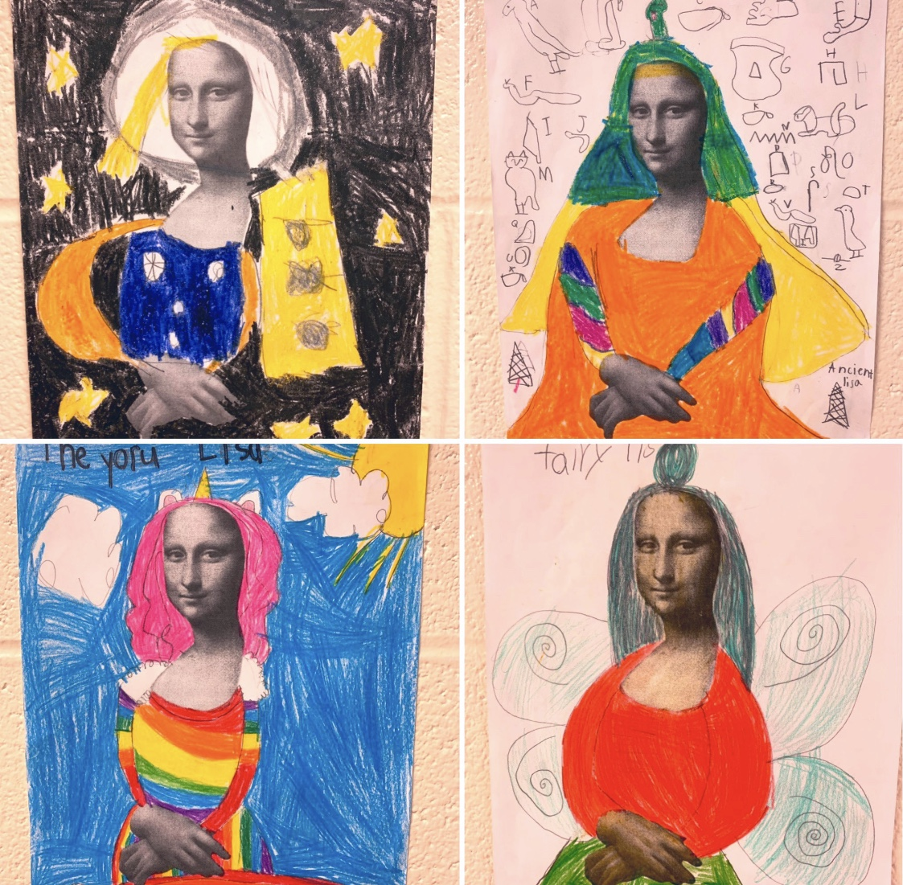

Now it’s YOUR turn! Have fun, and don’t forget to send me a picture of your creation! 😊

The Mona Lisa Pop Art Template you will need is attached on the Blog. 😊