**DaVinci Helicopters**

Happy Monday!

This week’s lesson was inspired by all the “helicopters” I have seen floating around my yard.

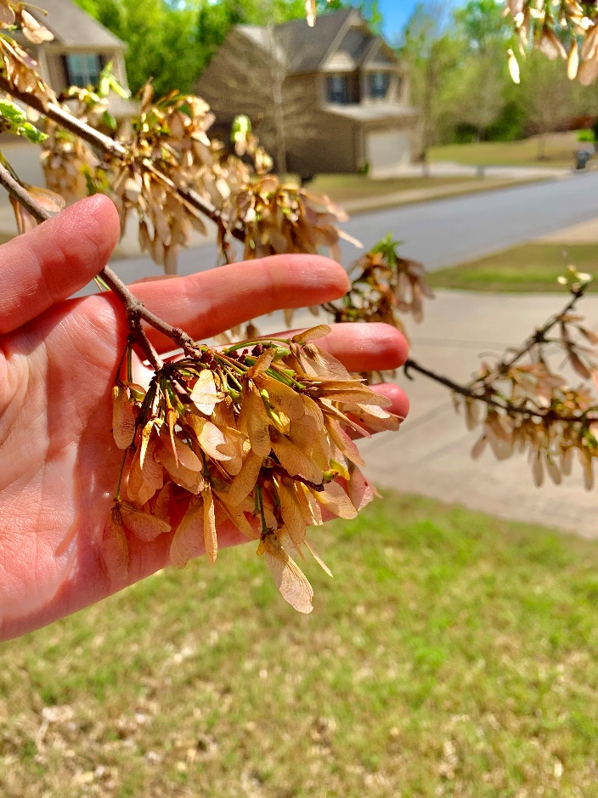 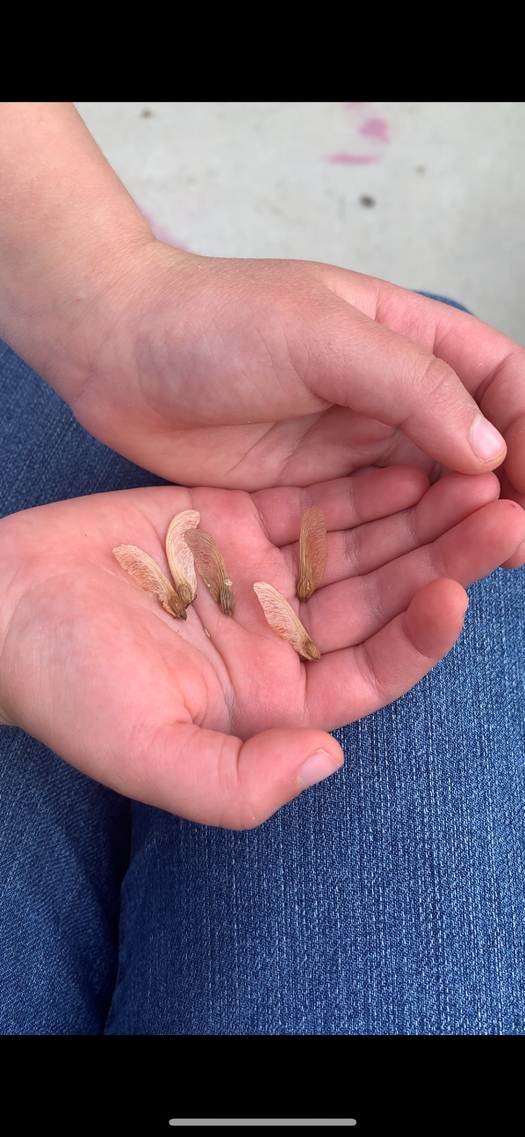

These helicopters are actually seeds from my fire maple tree in my front yard. When they fall out of the tree they twirl and spiral down in the hopes of planting a new maple tree. Can you find some of these helicopters in your yard? If so, check them out! Check out the shape of these helicopters. What do you think makes them fly so well? You might need this inspiration in the following lesson. 😉

Did you know that DaVinci was the first inventor of the helicopter? It didn’t work. 😊 But many of our ideas don’t work out the first time, do they? But, here’s what’s really cool: DaVinci came up with the idea of the Helicopter more than 400 years (400 years!!!!!) before a practical helicopter was actually invented! He was way ahead of his time!

Click here to check out DaVinci’s vision of a helicopter: <https://www.bing.com/videos/search?q=Helicopter+Leonardo+Sketch&&view=detail&mid=E84083AF50E29F077C85E84083AF50E29F077C85&&FORM=VRDGAR>

In the video take notice of his writing in his journal: everything is written backwards in mirror writing! Just like we practiced last week!

Today YOU are going to create several paper helicopters of different sizes to test to see which helicopter flies the best.

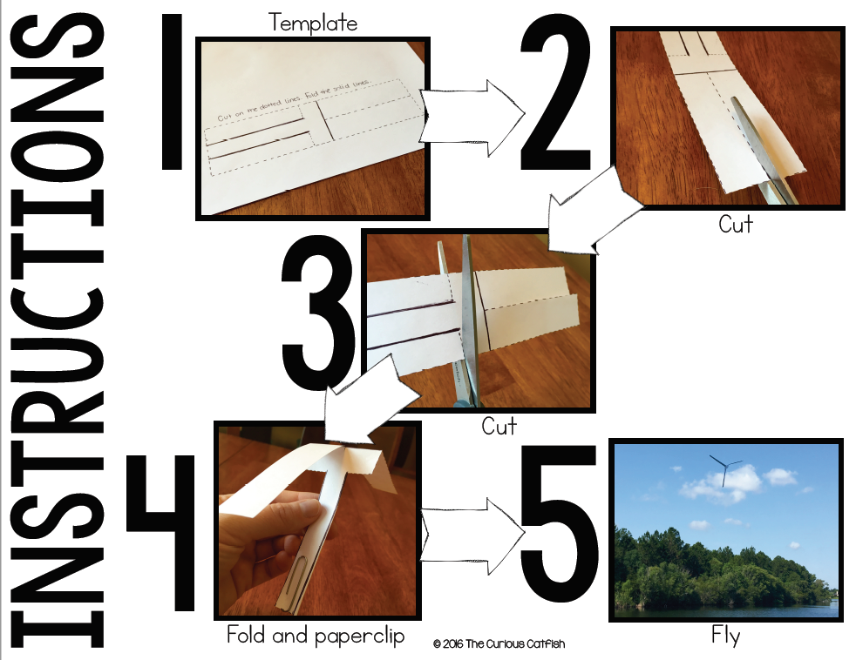

Below you will find:

3 different **standard** helicopters to cut out

3 different **mini** helicopters to cut out

3 different **extra-large** helicopters to cut out

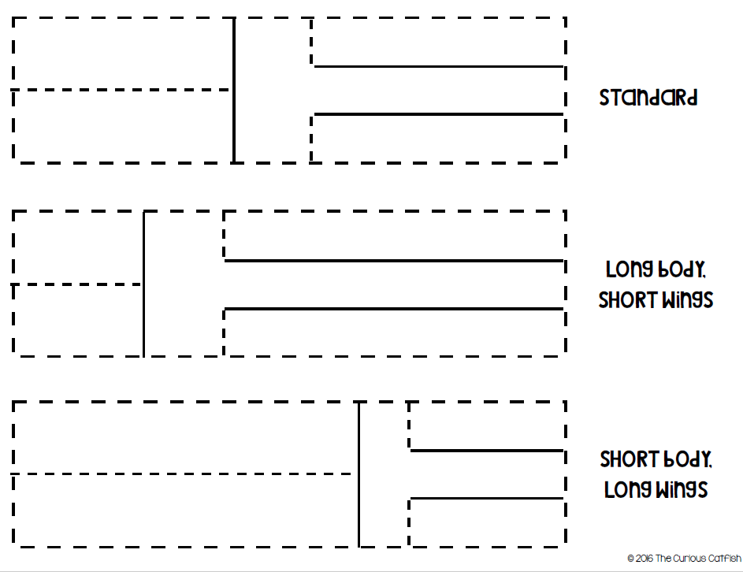

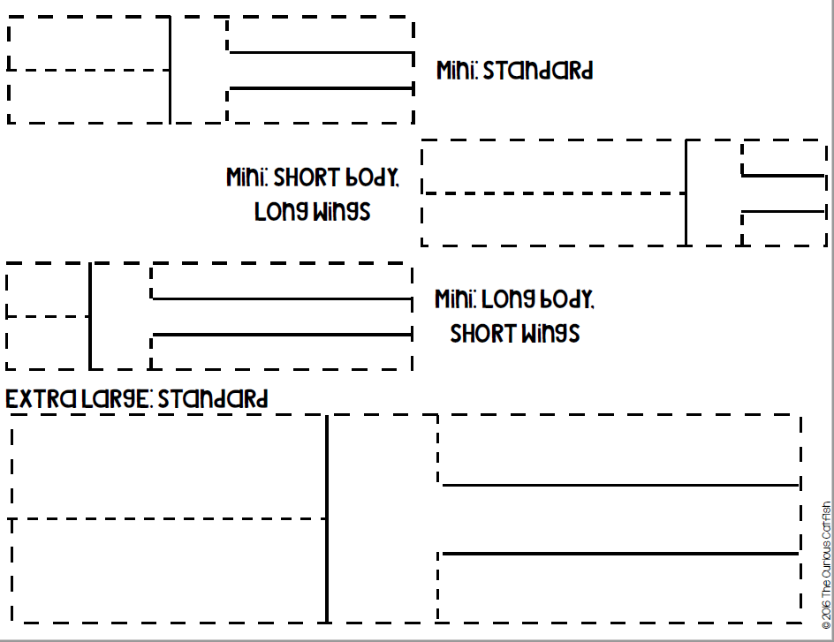

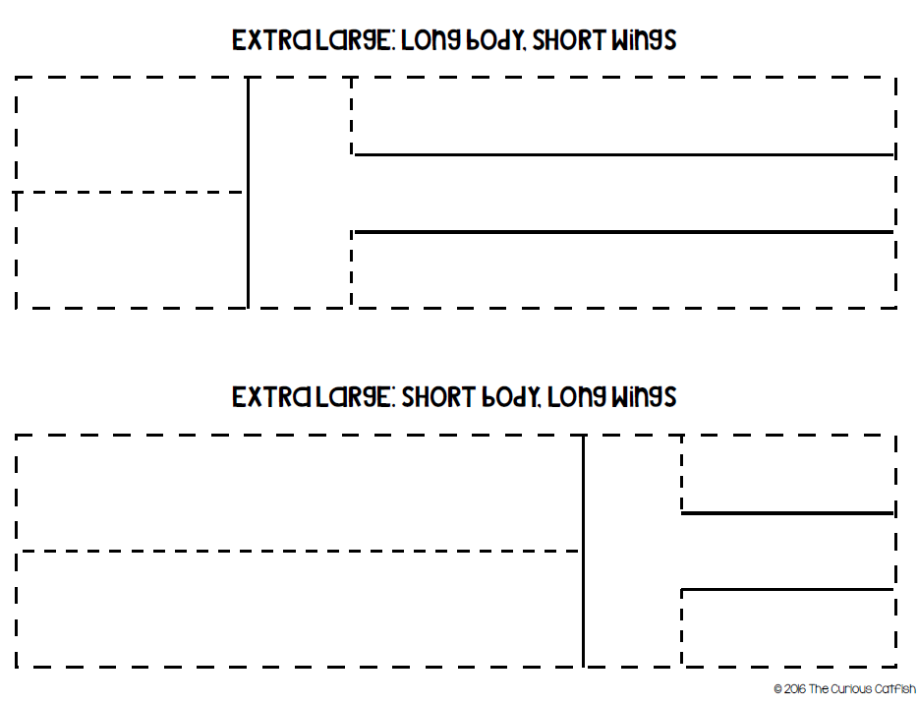

See how each set flies on its own. Then see if adding a paperclip to the bottom improves flight. Would more paperclips (adding weight to the bottom) improve flight even more?

If you have heavier paper, like cardstock, available investigate to see what differences the weight of the paper makes.

Have fun! Don’t forget to e-mail me pictures of your work or pictures of you working so I can give you credit! 😊

Below is a chart to help you record your findings:

Helicopter Data

Flew Well? YES NO Paperclips YES NO

**Standard**

Long Wings

Short Wings

**Mini**

Long Wings

Short Wings

**Extra Large**

Long Wings

Short Wings

**Cardstock**

Long Wings

Short Wings