Activity #1: Rebus Puzzles Warm-Up
Leonardo DaVinci was a huge fan of Rebus Puzzles! Can you solve the ones below? Each of these puzzles is a common saying. But I warn you…these puzzles are super tricky! Be persistent and try not to get frustrated. Make several guesses for each of these before looking for the answers on the next page. Have fun!!

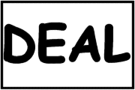
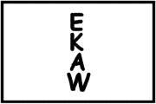

________________________________________________________________________________

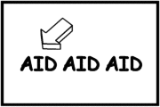
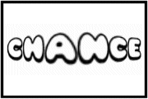

________________________________________________________________________________

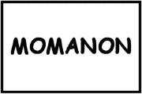
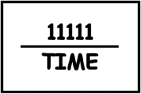

________________________________________________________________________________

Activity #2 – Understanding How to Solve Rebus Puzzles:
If you've never met rebus puzzles before, then this quick introduction will explain all you need to know. They are just little pictures, often made with letters and words, which cryptically represent a word, phrase, or saying. This page explains – with the help of examples – eight of the main ways in which a rebus puzzle might encode its solution.

POSITION
One of first things to look for is WHERE the words are located in the puzzle. In this example, the word MAN is inside the word MOON, so it is the man in the moon.

DIRECTION
HOW is the word written? When a word is spelled in any direction other than the usual left-to-right it is always part of the solution. The example illustrates wake up.

HIGHLIGHTING
Always look for an arrow or underlining. This is always a signal that this is where we should be looking for the clue. Here the arrow points to the first AID, showing us that the answer is first aid.

SIZE
Unusually large or small words or symbols may be used to show ideas like big, large, small, wide, etc. For example, this rebus puzzle represents
big deal.

NUMBER
Pay attention to HOW MANY TIMES a word is written. Sometimes numbers can sound like parts of words. This cryptic example shows 4 GOT 10 HEROES, and so the answer is forgotten heroes.
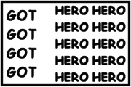
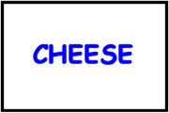
COLOR
If a word or symbol is not printed in black, then you can expect the color to be an important clue. In this easy example the word CHEESE is blue, so the answer is blue cheese.
STYLE
The style of the font can be important. It might illustrate ideas like tall, pretty, thin, slanted, etc. The fat letters in the example here lead the puzzler to figure out that the answer is fat chance.

SOUND
Very often rebus puzzles are phonologically cryptic. The sound will not always be exactly like the answer, but it will always be close enough to recognize, as in 1s upon TIME: once upon a time.

